Curtain Track Requirement Form

Track Shape
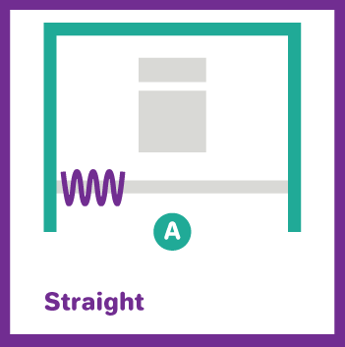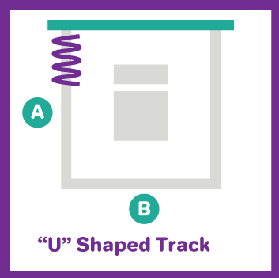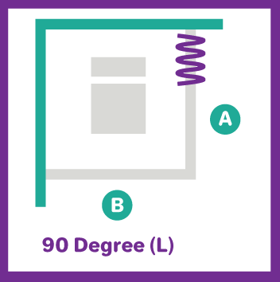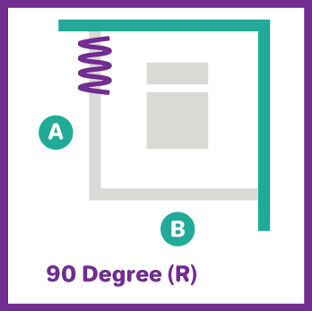

Track Dimensions (in CM)
Track 1 |  | Track 2 |  | Track 3 |  | Track 4
Shape: |  | Shape: |  | Shape: |  | Shape:
A |  | A |  | A |  | A
B |  | B |  | B |  | B

Track Style (Tick as Appropriate)
Track 1 |  | Track 2 |  | Track 3 |  | Track 4
 | Movatrack  (Compatible with Universal curtains) |  | Movatrack  (Compatible with Universal curtains) |  | Movatrack  (Compatible with Universal curtains) |  | Movatrack  (Compatible with Universal curtains)
 | Omnitrack  (Compatible with Fast-Fit, Universal and Uni-Glide curtains) |  | Omnitrack  (Compatible with Fast-Fit, Universal and Uni-Glide curtains) |  | Omnitrack  (Compatible with Fast-Fit, Universal and Uni-Glide curtains) |  | Omnitrack  (Compatible with Fast-Fit, Universal and Uni-Glide curtains)
 | Clinitrack  (Compatible with Fast-Fit and Universal curtains) |  | Clinitrack  (Compatible with Fast-Fit and Universal curtains) |  | Clinitrack  (Compatible with Fast-Fit and Universal curtains) |  | Clinitrack  (Compatible with Fast-Fit and Universal curtains)

Wall Fixings Requirements (Tick as Appropriate)
Track 1 |  | Track 2 |  | Track 3 |  | Track 4
 | Both ends of tracks to be fixed to the wall |  | Both ends of tracks to be fixed to the wall |  | Both ends of tracks to be fixed to the wall |  | Both ends of tracks to be fixed to the wall
 | Only one end of the track to be fixed to the walls |  | Only one end of the track to be fixed to the walls |  | Only one end of the track to be fixed to the walls |  | Only one end of the track to be fixed to the walls
 | Neither end of the track to be fixed to walls |  | Neither end of the track to be fixed to walls |  | Neither end of the track to be fixed to walls |  | Neither end of the track to be fixed to walls
 | Ceiling Support |  | Ceiling Support |  | Ceiling Support |  | Ceiling Support

Curtain Gliders (Tick if Required)
Track 1 | Track 2 | Track 3 | Track 4

Quantities (Number of each track required)
Track 1 | Track 2 | Track 3 | Track 4

Delivery Address:

Additional information for ceiling support:
Please use the below detail to help decide which ceiling support is required.
